Emergence
Introduction
Growth
Saturation
Declaine
Electronic retail
Turnover
Other category killers
Specialized outlets of clothes and footwear
DIY
Hypermarkets
Strong discount stores supermarkets
Traditional supermarkets
Department stores
Profit
Time
Turnover
Profitability
Permanence of customers
Competition
Low growth
Negative
Innovators
No
Fast competition
High yield
Special needs
Limited
Growth at high level
High, declining
Wide market
Extensive
Decline
Low
Special needs
Intensive
Figure 1. Lifecycle of retail formats in the European Union
Source: Planet Retail. Retrieved on March 1, 2016, from http://www.planetretail.net/presentations/ApexBrasilPresentation.pdf

Figure 2. Structure of food retail formats (2009-2014)
Source: Own calculation based on Global Power of Retailing (2011- 2016), Global power of retailing (2011-2016). Retrieved on March 2, 2016 from http://www2.deloitte.com/be/en/pages/consumer-business/articles/global-powers-of-retailing.html

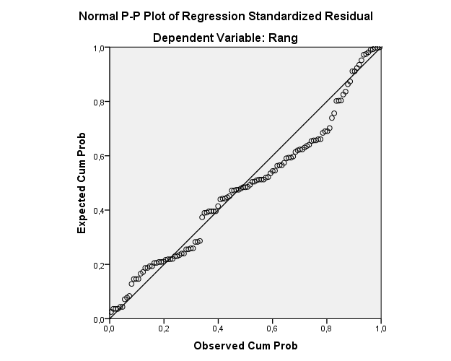
Figure 3. Normality test
Source: Own calculation

