Exploring the Role of Ownership in International Entrepreneurship:
How does Ownership Affect Internationalisation of Polish Firms?

Krzysztof Wach

A B S T R A C T
Objective: The article focuses on the role of ownership in the process of entrepreneurial internationalisation of the firm. The main objective of the article is to verify whether and how ownership impacts on the level of internationalisation.
Research Design & Methods: The study elaborates on three dimensions of ownership, which are ownership structure (foreign vs. domestic), family ownership and the characteristics of the owner (age, sex, global mindset and knowledge – the last two measured on a 5-point Likert scale). The V4 research survey results and the sample of 190 internationalised Polish businesses were used in order to meet the objective and verify the assumed hypotheses.
Findings: The investigated firms operating in Poland of foreign ownership are more internationalised, measuring by TNI, as these only of domestic capital. As a general rule, the investigated non-family firms are more internationalised than family firms as for the average TNI value. International attitude of the entrepreneur-owner affect the level of internationalisation of investigated firms: the higher values of attitude index, the higher values of TNI. Neither the age nor the sex of the entrepreneur-owner does not affect the level of internationalisation of the investigated firms.
Implications & Recommendations: it is obvious that knowledge is one of the key factors affecting the internationalisation, especially market choices, entry modes as well as the speed of internationalisation. Although, much has been done in this field, but it still needs further and deeper investigations.
Contribution & Value Added: The current study and its findings indicate that ownership is one of key aspects relevant for explaining the internationalisation of firms, but its impact on firms’ international behaviour is somewhat equivocal.
Article type: | research paper
Keywords: | International Entrepreneurship, International Business, Ownership, Family Firms,
JEL codes: | F23, L20
Received: 30 October 2017 |  | Revised: | Accepted:

Introduction
Ownership plays a special role in international business, and it can a factor stimulating the internationalisation of firms, however ownership can be researched into from the trichotomous perspective.
Firstly, ownership structure affects internationalisation, especially in two poles, namely foreign versus domestic ownership (Anil et al. 2014; Larimo/Arslan 2013), however ownership can affect internationalisation in different ways depending on the various ownership-stake-related aspects, thus these issues should be under careful empirical investigations. This paper tries to verify basic prior results linking ownership structure and internationalisation, but taking Polish economy as an example of emerging markets.
Secondly, for a few decades, ownership has also been discussing from the family perspective (Wiklund et al. 2013; Sciascia et al. 2012), distinguishing a separate research domain (family entrepreneurship or family business). Only two reviews of empirical studies have been published recently, nevertheless without no consensus on whether family ownership restrains or facilitates their internationalisation (Kontinen/Ojala 2010; Pukall/Calabrò 2014). From such a perspective, this article facilities to explore and disentangle the influence of familiness on the internationalisation (Merono/Monreal-Pérez/Sánchez-Marin 2015).
Thirdly, ownership is also a certain element of entrepreneurship research, where it is usually reduced to the characteristics of the owner (Kurek/Rachwał 2011), especially his/her international entrepreneurial orientation (Covin/Miller 2014) or global mindset (Hagen/Zuchella 2014). The basic characteristics of the owner includes four dimensions, namely sex, age, global mindset or knowledge. Rich literature in this field shows great importance of managerial behaviours for the internationalisation, however Hutzschenreuter, Pedersen and Volverda (2007) postulate to pay more attention to managerial intentionality to internationalize (global mindset), especially in SMEs. Recently, Pla-Barber and Alegre (2014) have investigated into the role of knowledge and learning in internationalisation. Based on their review, it is obvious that knowledge is one of the key factors affecting the internationalisation, especially market choices, entry modes as well as the speed of internationalisation. Although, much has been done in this field, but it still needs further and deeper investigations. This is why, this paper aims at exploring these relations and the impact of basic characteristics of the owner on the process of internationalisation.
As a matter of fact, putting all these three dimensions of ownership into one research study seems to be interesting, despite being a unidimensional approach to ownership, but trying to put three separate dimensions together (making a tiny step towards the multidimensional approach to ownership). Additionally, it meets all features of the international entrepreneurship research, which gradually is beginning to emerge as the dominant perspective in international business studies. Furthermore, it seems this topic is rare in Central and Eastern Europe, including Poland (Puślecki et al 2014; Obłój/Ciszewska-Mlinarič 2014; Burton et al. 2008). Therefore, the purpose of this study was to examine whether and how ownership impacts on the level of internationalisation. Nevertheless, this article still uses the unidimensional approach to the ownership in internationalisation (three various dimensions of ownership are treated separately). The article uses the research sample of 190 internationalised Polish businesses. The survey was conducted in 2014 on a random sample, however the sample is not representative for the whole Polish business population.

Theoretical Framework and Hypotheses Development
International entrepreneurship
Few previous decades have caused that not only the global economy but also the theory of international business, have undergone a dramatic change, and the “new economic landscape requires a combination of entrepreneurship, innovation, and internationalization” (Hagen at al 2014:111). The concept of 'international entrepreneurship' (IE) came into being in late 1980s (Kohn 1988; Morrow 1988; McDougall 1989), however the theory of IE was developed in mid 1990s, mainly by McDougall, who together with Oviatt developed this theory in the following years (Oviatt/McDougall 1994; McDougall et al 1994; McDougall/ Oviatt 1996, 2000; Oviatt/McDougall 2005). International entrepreneurship has been developing very intensively now (Al-Aali/Teece 2014; Almor et al. 2014; Covin et al. 2014; Hennart 2014; Wach & Wehrmann 2014). International entrepreneurship (Coviello/Jones 2004; Coviello et al. 2011; Coviello et al. 2014), linking two research domains – entrepreneurship theory and international business theory (McDougall/Oviatt 2000; McDougall-Covin et al. 2014; Zucchella/Sciabini 2007; Wach/Wehrmann 2014), is gradually beginning to emerge as the dominating approach within the internationalisation theory (the leading approach towards business internationalisation process) (Schweizer et al. 2010; Vahlne/Ivarson 2014; Jones et al. 2011; Coviello et al. 2014). International entrepreneurship specifically examines and prioritises the role of the entrepreneur as a key factor in the internationalisation process of the firm, especially of SMEs (Wach 2015) alongside the external environment and the entrepreneurial process constituting the triad of international entrepreneurship or entrepreneurial internationalisation (Glodowska/Pera/Wach 2016).
There are different and numerous approaches towards international entrepreneurship studies. For instance, Hagen and Zuchella (2014) point out four research perspectives. Firstly, studies into a firm-level behaviour of entrepreneurial internationalisation over time exploring timing and speed of the internationalisation process (Jones/Coviello 2005). Secondly, studies into international entrepreneurial dynamics enabling to recognise, discover and exploit new business opportunities in an international context (Mathews/Zander 2007; Oyson/Whittaker 2012). Thirdly, studies combining entrepreneurial internationalisation and corporate life cycle (CLC), which explore behaviour of entrepreneurial firms, especially born globals, at different stages of development (Gabrielsson et al. 2008). Fourthly, the dynamic capabilities perspective is widely used in international entrepreneurship studies (Weerawardena et al. 2007; Freiling/Zimmermann 2014). This approach explains the role of the entrepreneur, the learning process as the knowledge as the outcome, in the entrepreneurial internationalisation. Of course, we can also support other perspectives to be included. For instance, Hagen and Zuchella (2014) link international entrepreneurship and high-growth entrepreneurship studies, introducing even a new tern ‘born to run’ for high-growth born globals. Another very interesting perspective is linking innovation and international entrepreneurship (Hagen et al. 2014), as innovation is an indispensable and a prerequisite for all entrepreneurship studies.
The developments in international entrepreneurship and interlinked international business need to be complemented with parallel and supplementary research streams originated from entrepreneurship theory. Therefore, there is another side of entrepreneurial internationalisation (international entrepreneurship), which is the issue of ownership, understood in there different dimensions, as it was mentioned above.

Ownership Structure and Internationalisation
The level of ownership in overseas subsidiaries is a crucial issue for researchers in international business (Hennart 2009). Many aspects of capital control and foreign ownership have been investigated so far, however the recent studies still show that there is no clear consensus.
Ownership structure of foreign affiliates has been one of the main themes in the international business studies worldwide. Fernandez and Nieto (2006) provide empirical evidence that a corporate blockholder supports the internationalisation of SMEs (a sample of 6,000 family SMEs in Spain). Using a sample of 1,324 Italian manufacturing SMEs, Cerrato and Piva (2012) provide empirical support that the presence of foreign shareholders positively affects the likelihood of going international. Such a positively relation is clearly illustrated by many research studies around the globe, and it is obvious that international investor provides unique knowledge on international markets (Bartha/Gubik 2014; Wach, 2014), making the international commitment much easier implementing the assumptions of the stages U-model of internationalisation (Johanson/Vahlne 1997; Johanson/Wiedersheim-Paul 1975), especially supporting by the networking (Johanson/Vahlne 2009; Gorynia/Jankowska 2008) and international links of a foreign investor.
It is worth to check whether such positive correlation between the foreign ownership and the level of internationalisation occur in Polish economy as one of the broadly understood emerging markets, thus the first research hypothesis to be tested in this research study is as follows:
H1: | Firms operating in Poland of foreign ownership are more internationalised, measuring by TNI (transnationality index), as these only of domestic capital.

Familiness and Internationalisation
So far several studies have addressed the issue of family ownership in international entrepreneurship. Sciascia et al. (2012:15) emphasize that the empirical research “results of the role of family ownership in” the phenomenon of international entrepreneurship “are inconsistent”. Kontinen and Ojala (2010) as well as Pukall and Calabrò (2014) have prepared recently a review of empirical studies linking familiness and internationalisation and they concluded that there is no consensus on whether family ownership restrains or facilitates their internationalisation. On one hand, some studies show that family firms are much less internationalised than the other. On the other hand, some studies reveal that familiness affects positively internationalisation. It proves that there is still a research gap and these relations should be still investigated (Wach 2015).
Zahra (2003) empirically supports the positive influence of family ownership on the internationalisation, especially its scale and scope (a sample of 409 manufacturing firms from the USA), while Fernandez and Nieto (2005; 2006) show that family ownership negatively influences on the internationalisation process measured by export intensity. Cerrato and Piva (2012) empirically confirm that the family involvement negatively influences the likelihood to export (p < 0.05), while “the presence of managers from outside the family is positively associated with the firm’s choice to enter international markets” (p. 634). There is also another side of this argument, introduced by Sciascia et al. (2012:16), who empirically “confirmed the inverted U-shaped relationship between family ownership and international entrepreneurship” (a sample of 1,035 family firms from the USA using an online questionnaire). Their data show that “the percentage of family ownership at which international entrepreneurship results at a maximum is 53%” (p. 22). Based on the database of SMEs listed on the Taiwan Stock Exchange (panel date for 77 firms for the years 2000-2007), Chen, Hsu and Chang (2014) found that high family ownership may promote internationalisation. Majority of researchers from Poland reveal that family-firms are less internationalised than the rest, however some researchers show that family firms listed on the stock exchange are more internationalised (Daszkiewicz/Wach 2014; Wach/Wojciechowski 2014).
Merono et al. (2015) suggest that there is an evident need for further investigations disentangling the influence of familiness on the internationalisation, thus taking into account the existing knowledge gap, the second research hypotheses to be tested in this research study was as follows:
H2: | Familiness of ownership does not affect the internationalisation level, thus there is no difference between family and non-family firms as for TNI average value.

Entrepreneur Characteristics and Internationalisation
Last but not least dimension of ownership in international entrepreneurship is the entrepreneur-owner, who is a kind of ‘a hub and a spoke’ in the international entrepreneurship theory and research studies. Most researchers advocate that the entrepreneur-owner individual-specific factors, especially these mainly relate to characteristics of the entrepreneur positively impact the entrepreneurial internationalisation process (Ruzzier/Hisrich/Antoncic 2006). According to the various prior research studies, these are such as age, education, and work experience (Terjesen et al. 2010).
Hutzschenreuter, Pedersen and Volverda (2007) discerned a knowledge gap, which make them to call for paying more attention to managerial intentionality to internationalize, which is also recognised, by other researchers, as a global mindset (Hagen/Zuchella 2014). This issue is especially important in SMEs and international entrepreneurship studies.
Johanson and Vahlne (2009) perceive the internationalisation as a process of learning and knowledge accumulation. Recently, many empirical research results linking various aspects of knowledge and internationalisation have been published. Knowledge affects especially market choices, entry modes as well as the speed of internationalisation. For Pla-Barber and Alegre (2014) it is evident that knowledge is one of the key factors affecting the internationalisation, and in their editorial they call for further research exploring the exact role of knowledge in the internationalisation process. Ruzzier, Hisrich and Antoncic (2006, p. 490) conclude that entrepreneurial knowledge facilitates the recognition of new opportunities, especially in international markets.
The above mentioned two aspects of the entrepreneur’s (owner’s / manager’s) characteristics are promising in the context of international business, but the classical approach to international entrepreneurship deals also with the basic characteristics of the entrepreneur-owner such as his/her sex or age (Ubrežiová/Wach/Horváthová 2008). Ruzzier, Hisrich and Antoncic (2006) emphasise that entrepreneurs and their individual characteristics play an important role in international entrepreneurship and international behaviours of firms, what is more they state “we cannot neglect the importance of entrepreneurs, widely recognized as the main variables in SMEs’ internationalization” (p. 489), this is why these basic aspects were included in the study presented in this article.
Although, much has been done in this field, but it still needs further and deeper investigations. This is why, this paper aims at exploring these relations and the impact of basic characteristics of the owner on the process of internationalisation. The research hypotheses to be tested in this research study were as follows:
H3: | Both international attitude and prior knowledge of the entrepreneur-owner affect the internationalisation level of investigated firms: the higher values of attitude and knowledge indices, the higher value of TNI.
H4: | The age and the sex of the entrepreneur-owner does not affect the level of internationalisation of the investigated firms.

Research Methodology
In order to gather the empirical material, a quantitative research method was applied (Creswell 2014; Fowler 2009). The main research method for non-experimental quantitative research, which was applied in this study, was the research survey using a questionnaire for data collection “with the intent of generalizing from a sample to a population” (Creswell 2014:13). The survey was conducted in 2014.
Computer-assisted web interviewing (CAWI) was applied as the main survey method. This means that respondents (usually members of top management teams) answered the questions on their own using an online questionnaire, which was password protected. The request to fill in the online questionnaire was sent to approximately 7,000 Polish firms via a special dedicated e-mail, followed by a telephone conversation request, and 274 questionnaires were submitted, which means that the response rate was around 4%. Of these, 190 completely filled in questionnaires representing all 16 regions of Poland were selected for further statistical processing. As mentioned above the sample consists of 190 internationalised businesses from Poland representing all 16 administration regions, however 2 regions were overrepresented (see Table 1).

Table 1. Characteristics of the research sample (in %)
Size of the Firms |  | Age of the Firms
micro  small  medium-sized  large | 23  23  30  24 | 30 and more  20-29  19-10  9 and less | 18  33  26  23
Sector of the Economy |  | Scope of the Firm
agriculture  industry  service | 3  42  55 | mainly domestic  cross-border  only EU  within and beyond EU | 17.6  2.8  16.7  62.9

Management perceptions of firm-level variables are often used in entrepreneurship research (Naman/Slevin 1993), and these perceptions can be obtained from interviews or from surveys using questionnaires. “One potential advantage of perceptual approaches is a relatively high level of validity because researchers can pose questions that address directly the underlying nature of a construct” (Lyon et al. 2000: 1058).
The questionnaire was divided into four parts dedicated to different aspects under investigation, such as (i) the characteristics of the firm; (ii) the characteristics of the top management team; (iii) the characteristics of the industry; and (iv) the patterns of internationalisation.
Some variables were measured on an instrument as a continuous score (e.g. sex, age, number of employees) or discrete scores, while the majority of the questions were measured in a categorical ways (e.g. type of the applied strategy) which are connected to nominal variables, including also the interval scale from 1 to 5 of the Likert scale. The investigated top management teams were asked to evaluate (from extremely low to extremely high) their global mindset and knowledge by using five different aspects (motivation to go international, cosmopolitism and international openness, knowledge on international markets, experience in international markets, professional business experience in general).
Dichotomous variables were used very often to divide the population; however, in other cases dummy variables were used (e.g. traditional vs. rapid internationalisation). Two basic types of variables were applied – single indicators as well as overall assessment indexes. The single indicators were based directly on the questionnaire answers without any changes. On that basis, standardised indicators consisting of a couple of the single indicators, i.e. the overall assessment indexes, were applied. Each of the overall assessment indexes was constructed through the sum of values indicated by the respondents for each question, and then it was divided by the sum of maximum values possible to be obtained. Finally, the averaged assessment was obtained, standardised in the interval from 0 to 1 (given in percentage in the interval from 0 to 100).
Based on the literature review, of which brief summary was presented above, the research framework includes three main independent variables (ownership structure, family ownership and the characteristics of the owner), while internationalisation level measured by TNI (transnationality index) is the dependent variable (Figure 1).

Figure 1. Conceptual research framework of the study

The statistical calculations were made by the use of the statistical software Statistica® PL v. 10. In the empirical study, the level of the statistical significance (alpha or α) for statistical hypotheses testing was considered as 0.05. Apart from the well-known basic descriptive statistics, in order to verify the assumed hypothesis the following interferential statistical tests were applied: multivariate regression, Pearson Chi-square, the Pearson’s correlation coefficient (PCC), the regression analysis, the Kruskal-Wallis one-way analysis of variance, the Mann-Whitney U test; one-way ANOVA analysis, as well as the Levene test, the Brown-Forsyth test and the post-doc RIR Tukey test.

Empirical Findings
The transnationality index (TNI) was used as the dependent variable. It is one of the better and universal measures applicable for both SMEs and large companies (Wall et al. 2010, Dunning/Lundan 2008; Johnson/Turner 2010). TNI index expresses the intensity of investing and localising abroad particular functions and/or operations of the firm. It is calculated as a weighted average of the three shares taking into account the relationship of foreign assets (A_{F}) to the total assets (A_{T}), foreign sales (S_{F}) to total sales (S_{T}) and foreign employment (E_{F}) to total employment (E_{T}). This index is expressed as a percentage, and mathematically takes the form:
$$TNI= \frac{\frac{A_{F}}{A_{T}}+\frac{S_{F}}{S_{T}}+ \frac{E_{F}}{E_{T}}}{3}*100 [\%]$$
The TNI index can reach values between 0 and 100 (usually expressed in %), whereby 100 means the most internationalised business. The values among the investigated businesses varied from 1 to 77.33 (Figure 2). The average value was almost 18. Only one fourth of all investigated businesses reached at least 30. Only one out of ten firms noted more than 50 (the ninth percentile was 49.83333).

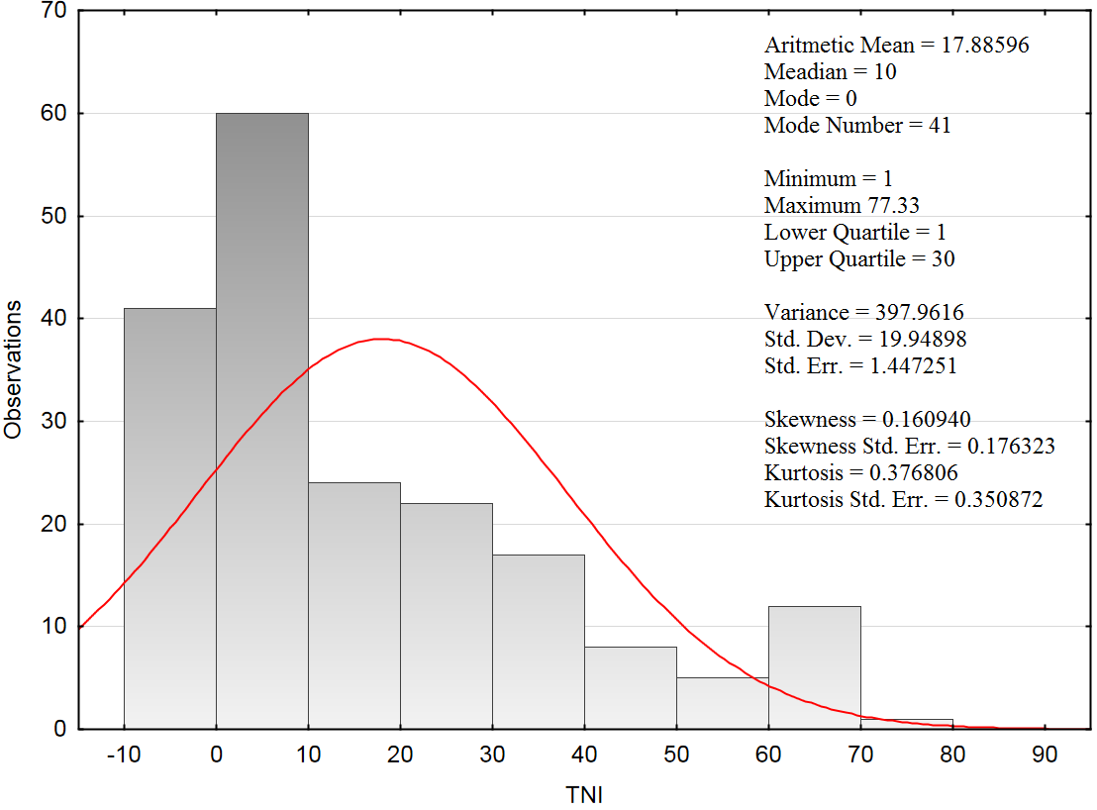
Figure 2. Distribution and descriptive statistics for the TNI values of the investigated businesses

In the literature it is widely argued and evidenced that small and medium-sized enterprises (SMEs) are usually less internationalised than large companies. Up to a point, the size of the investigated firm matters, nevertheless not statistically significant using the Kruskal–Wallis one-way analysis of variance by ranks (H [3,190] = 2.531450, p = 0.469) as well as the Mood’s median test (Chi-square = 2.521771, df = 3, p = 0.4714). On the whole, large and medium-sized companies are more internationalised (TNI = 21.8 and 20.6 respectively), while the small and micro businesses less, but in a reverse order (12.7 and 15.4 respectively).

Foreign Ownership
The Pearson’s correlation coefficient (r = 0.42, p = 0.000) demonstrates the positive average linear relationship between foreign ownership (expressed as 0-100%) and the level of internationalisation measured by TNI (expressed as 1-100%) (Figure 3).

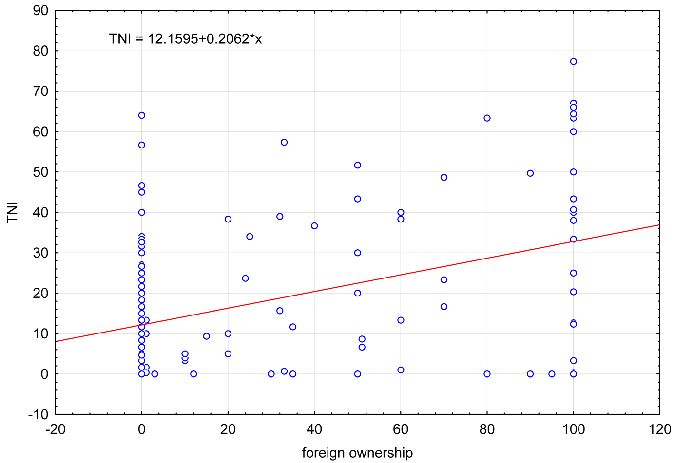
Figure 3. Scatterplot linking foreign ownership and business internationalisation level

To evaluate the relation between the TNI as the dependent variable and the foreign ownership (FO) as the independent variable, the regression analysis was applied. Based on the calculations, we can conclude that the estimated model can explain only about 17.5% the variability of the original TNI (R² = 0.17505628) at the multivariate correlation coefficient R = 0.41839. It is rather a low value as 82.5% of the variance is a random or can be explained by the influence of others, not included in the model, the independent variables. Nonetheless, the average difference between observed values of TNI and the theoretical values amounts to 18.167. The value of F statistics ([1,188], 39.894) and the corresponding level of the test probability p = 0.000000 confirms statistically significant relationship. What is more, the value of t statistics (6.3162) recounts that the evaluation of the regression coefficient differs significantly from zero. The estimated equation of the regression takes the form of TNI = 12.1595 + 0.2062*FO. These findings suggest that the change of 1 p.p. in foreign ownership causes by the change of 0.2 p.p. in TNI. The results of this study from Poland are in conformity with the above mentioned results from Spain (Fernandez/Nieto 2005) and from Italy (Cerrato/Piva 2012).

Family Ownership
Moving to another ownership dimensions, the ANOVA one-way variance was applied to examine whether there is the dependence between the familiness (family versus non-family ownership) and the internationalisation level (TNI). The normality of distribution allows to use the variance analysis (F = 6.15, p = 0.0140). The results of F test suggest that TNI value is different among family and non-family ownership (the null hypothesis was rejected). Descriptive statistics bring more lights how to interpret the results in details (Table 2). The average internationalisation level of family firms is only 13.79%, while the TNI value for non-family firms is higher and amounts to 20.94%. TNI value exceeds 32.33% in case of only 10% of family firms, whilst the ninth percentile for non-family firms is 63.33%, which simultaneously is the maximum TNI value for family firms. The results from Poland are not surprising, as they are in line with the empirical evidence from Spain (Fernandéz & Nieto, 2005; 2006) and from Italy (Cerrato/Piva 2012).

Table 2. Two-way cross-tabulation for familiness ownership and TNI
Age | N | Mean | Std. Dev. | Std. Err. | Min | Q25 | M | Q75 | Max
Non-family firms | 109 | 20.94 | 22.66 | 2.17 | 0 | 0.67 | 12.33 | 38.33 | 77.33
Family firms | 81 | 13.79 | 14.73 | 1,63 | 0 | 1.67 | 9.33 | 23.33 | 63.33
All firms in total | 190 | 17.88 | 17.88 | 1.45 | 0 | 1.00 | 10.00 | 30.00 | 77.33

Owner’s Characteristics
Last but not least, the entrepreneur’s (owner’s) characteristics was taken into special consideration by examining their sex, age, global mindset (attitude towards internationalisation) and knowledge on international markets, anyway three last variables are quantitative.
Regardless of the fact, the correlation between the age of the owner-entrepreneur is statistically nonsignificant, we can conclude that there are no grounds to reject the null hypothesis and the high value of the test probability (r = 0.01, p = 0.838) as well as very low coefficient close to zero, can mean that there is every possibility that the null hypothesis is true. Examining the scatterplot may suggest that the value of TNI doesn’t depend on the age of the entrepreneur as the spread of the cases is smooth and even.
As for the owner’s sex, which is measured on a nominal scale (male, female), however 90% of the sample were men (against 10% of women), and the respective calculations and especially due to the test probability (p = 0.83), there is no presumption against the neutral hypothesis. While there is no significance, it cannot be denied that studying the interaction plot (Figure 4) shows that as a general rule the sex doesn’t impact the internationalisation level among the investigated owners-entrepreneurs, but the sub-samples are not large enough (19 women) from a statistical point of view.

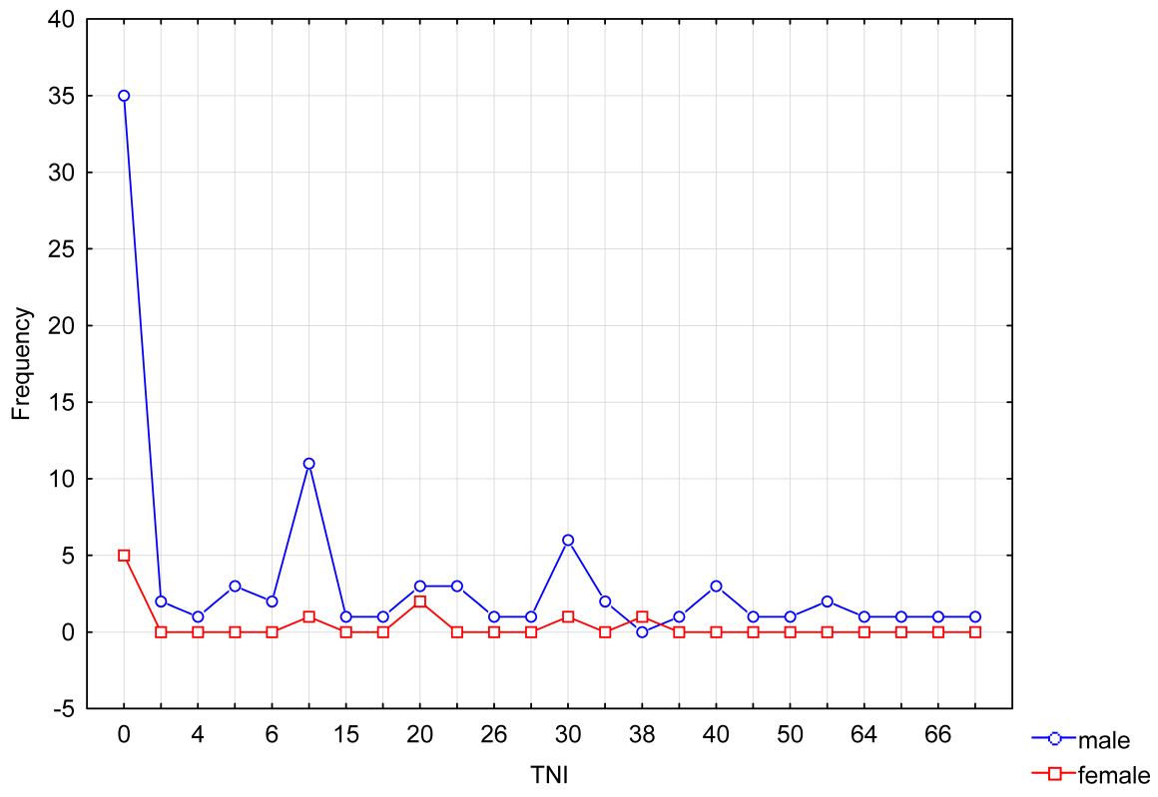
Figure 4. Interaction plot linking the owner’s sex and internationalisation level

To characterise the owner-entrepreneur’s features, two standardized variables were prepared based on a couple of questions evaluating the attitude and the knowledge on the Likert 5-scale expressed as 0-1 (or 0-100%). The coefficient r = 0.22 expresses the weak correlation between the openness to international markets as well as cosmopolitism of the owner and the value of TNI, at the very strong presumption against neutral hypothesis (p = 0.002). The scatterplot shows that the TNI is above 50%, whereas the attitude indicator is between 0.8 and 1.0 (0 means the lowest openness and cosmopolitism, and 1 the highest), otherwise its value is between 0.15 and 1.0. The coefficient r = 0.09 at no presumption against the neutral hypothesis (p = 0.212) doesn’t lead to the same conclusions. Based on the numbers, it is evident that the larger sample is needed, however the scatterplot reveals that the TNI values can reach the highest values at both very low and very high knowledge and experience in international markets, which can be a bit confusing and difficult to explain or even hard to accept.

Multidimensional ownership
The first step in the presented research results was to verify unidimensional dependences and relations between the internationalisation and three separate dimensions of ownership. Furthermore, the multidimensional analysis of ownership in internationalisation seems to be interesting as a kind of the novelty. This is why such an attempt at exploring that was made.
Multivariate regression was performed in order to verify the impact of independent variables describing ownership on TNI as a dependent variable. The results of the starting model (model 0) cannot be interpreted as the collection of variables is heteroscedastic (White’s test), which means that there are sub-populations that have different variabilities from others. That is why the answers were divided into four groups according to the level of TNI taking into considerations four quartiles (Table 3). Technically speaking estimates are unsatisfactory – the first group results are difficult to explain and discuss (a minus sign), while there are not proofs for the second and the third group. There are only two clear and significant relations for the most internationalised firms (model 4). The change of foreign ownership and the change of global mindset cause the change of TNI. As for model 1, the least internationalised investigated firms (n = 54) are manged by the owners with low global mindset (negative impact with a minus sign), so this can be a good explanation why their internationalisation level is low. As for model 4, among the most internationalised investigated firms (n = 41) global mindset plays important role in the internationalisation process and level.

Table 3. Multivariate regression linking ownership and TNI
Model 1: TNI up to Q1 (0 – 1.7>
n = 54, R̂2 = 0.175397, corrected R̂2 = 0.070128
F(6,47) = 1.666183, p = 0.150385
dependent variables | b* | std. err. b* | t | p-value
const | 0.03810 | 0.73804 | 1.407 | 0.1661
foreign ownership | –0.00658 | 0.00246 | –2.676 | 0.0102
family ownership | 0.04837 | 0.18716 | 0.258 | 0.7972
owner’s gender | 0.51524 | 0.32502 | 1.585 | 0.1196
owner’s age | –0.01194 | 0.00938 | –1.272 | 0.2096
owner’s global mindset | –1.39442 | 0.78134 | –1.785 | 0.0808
owner’s knowledge | 0.96265 | 0.73581 | 1.308 | 0.1971
Model 2: TNI up to Q2 (1.7 – 10>
n = 41, R̂2 = 0.057866, corrected R̂2 = –0.108394
F(6,34) = 0.348044, p = 0.906082
dependent variables | b* | std. err. b* | t | p-value
const | 7.41770 | 4.22838 | 1.754 | 0.0884
foreign ownership | –0.02372 | 0.03052 | –0.7771 | 0.4425
family ownership | –0.48654 | 0.96696 | –0.5032 | 0.6181
owner’s gender | 0.38380 | 1.60500 | 0.2391 | 0.8124
owner’s age | –0.01860 | 0.04621 | –0.4026 | 0.6898
owner’s global mindset | –1.26613 | 3.60575 | –0.3511 | 0.7276
owner’s knowledge | 2.04757 | 2.47372 | 0.8277 | 0.4136
Model 3: TNI up to Q3(10 – 30>
n = 41, R̂2 = 0.146958, corrected R̂2 = –0.003579
F(6,34) = 0.976225, p = 0.456217
dependent variables | b* | std. err. b* | t | p-value
const | 10.73430 | 10.13210 | 1.059 | 0.2969
foreign ownership | –0.04368 | 0.02944 | –1.483 | 0.1472
family ownership | –0.01564 | 2.12436 | –0.007 | 0.9942
owner’s gender | –5.19369 | 4.56842 | –1.137 | 0.2635
owner’s age | 0.08054 | 0.09986 | 0.806 | 0.4256
owner’s global mindset | 12.17150 | 8.98235 | 1.355 | 0.1843
owner’s knowledge | 0.80518 | 7.73290 | 0.104 | 0.9177
Model 4: TNI above Q3 (30 – 100>
n = 41, R̂2 = 0.527084, corrected R̂2 = 0.443628
F(6,34) = 6.315730, p = 0.000155
dependent variables | b* | std. err. b* | t | p-value
const | 7.50644 | 14.63590 | 0.5129 | 0.6114
foreign ownership | 0.17999 | 0.04353 | 4.1340 | 0.0002
family ownership | –2.91739 | 4.07656 | –0.7156 | 0.4791
owner’s gender | 3.87760 | 5.80287 | 0.6682 | 0.5085
owner’s age | 0.14464 | 0.14246 | 1.0150 | 0.3171
owner’s global mindset | 46.5149 | 14.55780 | 3.1950 | 0.0030
owner’s knowledge | –25.4346 | 11.3872 | –2.2340 | 0.0322

There is no doubts that the attempt to catch multidimensional ownership phenomenon was very welcome and desired indeed, nevertheless there are no sound and broad findings. Even recently published works in highly-ranked journals still deal with the ownership as the unidimensional problem, such as ownership concentration (major shareholder’s international preference), ownership structure (state vs. non-state), family ownership. Oesterle, Richta and Fisch (2013: 195) support the ‘‘cubic stretched u-shaped’’ relationship between the stake of the largest owner and a firm’s international diversification” understood as the international preference of the owner. This result are with line of the result presented in this article that global mindset of owners stimulates internationalisation, but still it is unidimensional approach. Based on the research of Zhang et al. (2016) the relation between ownership (measured only as state-owned enterprises, SOE and non-state-owned enterprises, none-SOE) and internationalisation was supported, nevertheless no detailed dependencies within the ownership characteristics were supported and shown, as the researchers conclude that “we cannot claim a thorough understanding of the impact of ownership as a boundary condition of our conceptual and empirical knowledge about the internationalization behavior of Chinese SME” (p. 532). D’Angelo, Majocchi and Buck (2016), based on their empirical results, were also able only to make general remarks: family controlled firms are less internationalised than family influenced firms, as well as the role of family managers and external managers is different in these two types of family firms. Also Lin (2012) based on his 772 publicly-listed firms from Taiwan (2000-2008) reports that there is no clear evidence how family impacts the internationalisation. To conclude, unfortunately also results presented in this article suggests that there is still a need to deepen this research problem, nevertheless it clearly illustrates that each step forward, even the attempt presented here, is needed for further studies.

Conclusions
All in all, it is apparent from the foregoing arguments that international entrepreneurship is becoming the major approach towards business internationalisation, exploring numerous aspects of international business from the entrepreneurship perspective. The fact of the matter is that many aspects of international business, even those well-grounded in the theory of entrepreneurship, are still unexplored in international context (international entrepreneurship). Therefore, this study was designed to explore some links between ownership and international entrepreneurship in Poland.
The initially assumed four research hypotheses (H1, H2, H3, H4), due to the calculations and obtained research results, were shaped, slightly changed and extended into five final hypotheses (H1, H2a, H3a, H3b, H4), which were confirmed:
H1: | Firms operating in Poland of foreign ownership are more internationalised, measuring by TNI, as these only of domestic capital. | confirmed
H2: | Familiness of ownership does not affect the internationalisation level, thus there is no difference between family and non-family firms as for TNI average value. | rejected
H2a: | As a general rule the investigated non-family firms are more internationalised than family firms as for the average TNI value. | confirmed
H3: | Both international attitude and prior knowledge of the entrepreneur- owner affect the internationalisation level of investigated firms: the higher values of attitude and knowledge indices, the higher value of TNI. | X
H3a: | International attitude of the entrepreneur-owner affect the level of internationalisation of investigated firms: the higher values of attitude index, the higher value of TNI. | confirmed
H3b: | The prior knowledge of the entrepreneur-owner concerning international markets affects the internationalisation level of investigated firms: the higher value of knowledge index, the higher value of TNI. | nonsignificant
H4: | The age and the sex of the entrepreneur-owner does not affect the level of internationalisation of the investigated firms. | confirmed

The current study and its findings indicate that ownership is one of key aspects relevant for explaining the internationalisation of firms, but its impact on firms’ international behaviour is somewhat equivocal. Based on the survey results and statistical calculations, the following conclusions should be drawn up:
- The level of internationalisation of investigated firms is rather moderate, measure by the TNI (on the scale from 1 to 100%), the average value was almost 18, while only one fourth of the firms exceeded 30 and one of ten firms noted more than 50. Taking into consideration the fact that the larger economy is, the less open it is, the level of internationalisation of investigated Firms is rather optimistic.
- Foreign ownership correlates with the level of internationalisation measured by TNI. The more foreign capital in the investigated firms, the more internationalised they are (Pearson’s correlation coefficient). What is more, the change of 1 percentage point in TNI is caused by the change of 0.2 percentage point in foreign ownership (regression). Similarly, Anil et al. (2014) more advanced entry modes (direct investment) are facilitated or constrained by the size and multinational experience of the firm and multinationalism, including foreign ownership) stimulates higher level of internationalisation.
- Investigated family firms operating in Poland are less internationalised that their counterparts of general businesses (variance analysis, F test, ANOVA). Similarly, relying on data from a sample of Spanish SMEs, Fernández and Nieto (2006) evidenced that internationalisation is negatively related to family ownership and positively related to corporate ownership. Also Merino and colleagues (2015), on a sample of 500 Spanish firms, found that the family experience positively affect internationalisation. This is partially in line with the results of Cerrato and Piva (2012). Using a sample of Italian SMEs, they evident that the involvement of the owing family negatively influences internationalisation, however after going international “both the degree of internationalisation and geographical scope in family-managed firms are not significantly different from nonfamily-managed firms” (p. 617).
- Global mindset understood as the international orientation of the entrepreneur/owner stimulates internationalisation (linear correlation). What is more, it paid a very important role in the most internationalised investigated firms (multivariate regression). The change of in TNI is caused by the change of the entrepreneur’s / owner’s intentionality to go internationalise. Similar results are included in various empirical research and discussed in reviews (Hutzschenreuter/Han/Kleindienst 2010; HutzschenreuterPedersen/Volverda 2007). Using a sample of 121 Polish firms, Ciszewska-Mlinarič (2015) indicates that global mindset is a key capability relevant for explaining the internationalisation, but its impact seems to be somewhat equivocal.

Empirical Limitations
Like all research, this study is not without some notable limitations. First of all, the research sample is not representative, thus it is not possible to absolutise the result over the whole population of Polish businesses, however it illustrates rightly and correctly the situation of firms operating in Poland. Nevertheless, the findings might not be entirely representative. Secondly, the survey and the perceptual approach have their own limitations as they use non-absolute data, nevertheless these techniques are very popular and enable a relatively high level of validity, commonly accepted by researchers worldwide (Lyon et at. 2000).

Future Research Directions
More studies in this area will be of interest. Firstly, future studies should seek to develop longitudinal research designs. Thus, this is just a preliminary research study. Nonetheless, it would be interesting to have panel data allowing to test entrepreneurial features of international business in more details.
Secondly, as for the owner characteristics, a particularly interesting study should examine entrepreneurial intentions and their antecedents at one point in time. In addition, it would be useful to investigate into the international entrepreneurial orientation (Covin/Miller 2014).
Thirdly, linking family ownership and international entrepreneurship in this study design is very preliminary. There is no absolute answer to the this question as for example the inverted U-shape curve (Sciascia et al. 2012) should be examined in Poland. Doubtless, the role of the family in international entrepreneurship seems to be still unexplored and needs further detailed research studies.

References
Al-Aali, A./Teece, D.J. (2014). International Entrepreneurship and the Theory of the (Long-Lived) International Firm: A Capabilities Perspective, in: Entrepreneurship Theory and Practice, 38(1): 95-116, DOI: 10.1111/etap.12077
Almor, T./Tarba, Sh.Y./Margalit, A. (2014). Maturing, Technology-Based, Born-Global Companies: Surviving Through Mergers and Acquisitions, in: Management International Review, 54 – in press, DOI 10.1007/s11575-014-0212-9
Anil, A./ Tatoglu, E./ Ozkasap, G. (2014). Ownership and market entry mode choices of emerging country multinationals in a transition country: evidence from Turkish multinationals in Romania, in: Journal of East European Management Studies, 19(4): 413-452.
Bartha, Z./Gubik, A.S. (2014). The Role of Business Knowledge in the Internationalisation Process of Hungarian Corporations (chapter 6). In: D. Kiendl-Wendner & K. Wach (Eds.), International Competitiveness in Visegrad Countries: Macro and Micro Perspectives (pp. 125-142). Graz: Fachhochschule Joanneum.
Bruton, G.D./Ahlstrom, D./Obloj, K. (2008). Entrepreneurship in emerging markets: where we are today and where we need to move to in the future, in: Entrepreneurship: Theory and Practice, 32(1): 1–14.
Cerrato, D./Piva, M. (2012). The internationalization of small and medium-sized enterprises: the effect of family management, human capital and foreign ownership, in: Journal of Management & Governance, 16(6): 617–644. DOI 10.1007/s10997-010-9166-x
Chen H.-L./Hsu, W.-T./Chang, Ch.-Y., (2014). Family Ownership, Institutional Ownership and Internationalization of SMEs, in: Journal of Small Business Management, 52(4): 771-789.
Ciszewska-Mlinarič, M. (2015). Global Mindset and Internationalization of Polish SMEs: Antecedents and Outcomes, in: Problemy Zarządzania, 13(1[2]), 93-113, DOI 10.7172/1644-9584.51.7
Coviello, N.E./Jones, M.V. (2004). Methodological issues in international entrepreneurship research, in: Journal of Business Venturing, 19(4): 485-508.
Coviello, N.E./Jones, M.V., & McDougall-Covin, P. (2014). Is International Entrepreneurship research a viable spin-off from its parent disciplines? In: A. Fayolle, P. Riot (eds.), Institutionalization of Entrepreneurship: Hopes and Pitfalls for Entrepreneurship Research, Routledge.
Coviello, N.E./McDougall, P.P./Oviatt, B.M. (2011). The emergence, advance and future of international entrepreneurship research — An introduction to the special forum, in: Journal of Business Venturing, 26(6), 625-631, DOI 10.1016/j.jbusvent.2011.07.002.
Covin, J.G./Miller, D. (2014). International Entrepreneurial Orientation: Conceptual Considerations, Research Themes, Measurement Issues, and Future Research Directions, in: Entrepreneurship Theory and Practice, 38(1):11-44, DOI: 10.1111/etap.12027.
Creswell, J.W. (2014). Research Design: Qualitative, Quantitative and Mixed Methods Approaches. Los Angeles, CA: SAGE Publications Inc.
D’Angelo, A./Majocchi, A./ Buck, T. (2016). External managers, family ownership and the scope of SME internationalization, in: “Journal of World Business”, 51(4): 534-547,
Daszkiewicz, N./Wach, K. (2014). Motives for Going International and Entry Modes of Family Firms in Poland, in: Journal of Intercultural Management, 6(2): 5-18.
Dunning J.H./Lundan, S.M. (2008). Multinational Enterprises and the Global Economy. 2nd ed., Chelterham–Northampton, MA: Edward Elgar.
Fernandez, Z./Nieto, M.J. (2005). Internationalization Strategy of Small and Medium‐Sized Family Businesses: Some Influential Factors, in: Family Business Review, 18(1): 77-89.
Fernandez, Z./Nieto, M.J. (2006). Impact of ownership on the international involvement of SMEs, in: Journal of International Business Studies, 37(3): 340-351.
Fowler, F.J. (2009). Survey Research Methods. 4th ed., Thousand Oaks, CA: Sage.
Freiling, J./Zimmermann, M. (2014). Internal and External Learning Races in ‘Born Transnationals’: What are the Driving Forces?, in: Entrepreneurial Business and Economics Review, 2(1): 19-35.
Gabrielsson, M./Kirpalani, M./Dimitratos, P./Solber, C./Zuchella, A. (2008). Born globals: propositions to help advance the theory, in: International Business Review, 17(4): 385-401.
Glodowska, A./Pera, B./Wach, K. (2016). International Environment and its Influence on the Entrepreneurial Internationalisation of the Firm: The Case of Polish Businesses, in: K. Wach & A. Żur (Eds.), Advancing Research in Entrepreneurship in Global Context: Conference Proceedings of the 8th ENTRE Conference. Kraków: Cracow University of Economics
Gorynia, M./Jankowska, B. (2008). Clusters - a Useful Concept of Increasing the Internationalization of SMEs. The Case of Furniture, Automotive and Boiler-making Clusters in Poland. In: An Enterprise Odyssey: Tourism, Governance and Entrepreneurship (pp. 1153-1162). Zagreb: University of Zagreb.
Gubik, A.S./Bartha, Z. (2014). SMI Internationalisation Index (SMINI) based on the Sample of the Visegrad Countries (chapter 2). In: A.S. Gubik & K. Wach (Eds.), International Entrepreneurship and Corporate Growth in Visegrad Countries (pp. 23-40). Miskolc: University of Miskolc.
Hagen, B./Denicolai, S./Zuchella, A. (2014). International entrepreneurship at the crossroads between innovation and internationalization, in: Journal of International Entrepreneurship, 12(2): 111-114.
Hagen, B./Zuchella, A. (2014). Born Global or Born to Run? The Long-Term Growth of Born Global Firms, in: Management International Review, 54(4): 497–525. DOI 10.1007/s11575-014-0214-7
Hennart, J.-F. (2009). Down with MNE-centric Theories! Market Entry and Expansion as the Bundling of MNE and Local Assets, in: Journal of International Business Studies, 40(9), 1432-1454.
Hennart, J.-F. (2014). The Accidental Internationalists: A Theory of Born Global, in: Entrepreneurship Theory and Practice, 38(1): 117-135, DOI: 10.1111/etap.12076
Hutzschenreuter, T./Han, U.-S./ Kleindienst, I. (2010), Exploring the role of managerial intentionality in international business, in: T. Devinney, T. Pedersen, L. Tihanyi (eds.), The Past, Present and Future of International Business & Management (Advances in International Management, Volume 23) Emerald Group Publishing Limited, pp.113-135.
Hutzschenreuter, T./Pedersen, T./ Volverda, H.W. (2007). The role of path dependency and managerial intentionality: A perspective on international business research, in: Journal of International Business Studies, 38(7), 1055-1068.
Johanson, J./Vahlne, J.-E. (1977). The Internationalization Process of the Firm: A Model of Knowledge Development and Increasing Foreign Commitments, in: Journal of International Business Studies, 8(1): 23–32.
Johanson, J./Vahlne, J.-E. (2009). The Uppsala Internationalization Process Model Revisited: From Liability of Foreignneess to Liability of Outsidership, in: Journal of International Business Studies, 40(9): 1411–1431.
Johanson, J./Wiedersheim-Paul (1975). The internationalisation of the firm: Four Swedish cases, in: Journal of Management Studies, 12(3): 305-322.
Johnson, D./Turner, C. (2010). International Business. Themes and Issues in the Modern Global Economy. 2nd ed., Oxon – New York, NY: Routledge.
Jones, N.V./Coviello, N. (2005). Internationalisation: conceptualising an entrepreneurial process of behaviour in time, in: Journal of International Business Studies, 36(2): 227-244.
Jones, N.V./Coviello, N., & Tang, Y.K. (2011). International Entrepreneurship Research (1989-2009): A Domain Ontology and Thematic Analysis, in: Journal of Business Venturing, 26(6), 632-659.
Kohn, T.O. (1988). International Entrepreneurship: Foreign Direct Investment by Small U.S.-based Manufacturing Firms, Unpublished DBA Thesis, Harvard University, Ann Arbor, MI (university microfilms).
Kontinen, T./Ojala, A. (2010). The Internationalization of Family Businesses: A Review of Extant Research, in: Journal of Family Business Strategy, 1, 97-107.
Kurek, S./Rachwał, T. (2011). Development of entrepreneurship in ageing populations of The European Union, in: Procedia. Social and Behavioral Sciences, 19, 397-405.
Larimo, J./ Arslan, A. (2013). Determinants of foreign direct investment ownership mode choice: Evidence from Nordic investments in Central and Eastern Europe, in: Journal of East European Management Studies, 18(2): 232-263.
Lin, W.-T. (2012). Family ownership and internationalization processes: Internationalization pace, internationalization scope, and internationalization rhythm, in: “European Management Journal”, 30 (1): 47-56.
Lyon, D.W./Lumpkin, G.T./Dess, G.G. (2000). Enhancing Entrepreneurial Orientation Research: Operationalizing and Measuring a Key Strategic Decision Making Process, in: Journal of Management, 26(5): 1055-1085, DOI 10.1177/014920630002600503.
Mathews, J./Zander, I. (2007). The international dynamics of accelerated internationalisation, in: Journal of International Business Studies, 38(3): 387-403.
McDougall, P.P. (1989). International versus Domestic Entrepreneurship: New Venture Strategic Behavior and Industry Structure, in: Journal of Business Venturing, 4(6), 387-400, DOI 10.1016/0883-9026(89)90009-8.
McDougall, P.P./Oviatt, B.M. (1996). New Venture Internationalization, Strategic Change, and Performance: A Follow-up Study, in: Journal of Business Venturing, 11(1), 23-42, DOI 10.1016/0883-9026(95)00081-X.
McDougall, P.P./Oviatt, B.M. (2000). International Entrepreneurship: The Intersection of Two Research Paths, in: The Academy of Management Journal, 43(5), 902-906, DOI 10.2307/1556418.
McDougall, P.P./Shane/Oviatt, B.M. (1994). Explaining the Formation of International New Ventures: The Limits of Theories from International Business Research, in: Journal of Business Venturing, 9(6): 469-487, DOI 10.1016/0883-9026(94)90017-5.
McDougall-Covin, P./Jones, M.V./Serapio, M.G. (2014). High-Potential Concepts, Phenomena, and Theories for the Advancement of Entrepreneurship Research, in: Entrepreneurship Theory and Practice, 38(1), 1-10, DOI 10.1111/etap.12090.
Merono, F./Monreal-Pérez, J./Sánchez-Marin, G. (2015). Family SMEs’ Internationalisation: Disentangling the Influence of Familiness on Spanish Firms’Export Activity, in: Journal of Small Business Management, 53(4), 1164-1184, DOI 10.1111/jsbm.1211
Morrow, J.F. (1988). International entrepreneurship: A new growth opportunity, in: New Management, 3(5), 59-61.
Naman, J.L./Slevin, D.P. (1993). Entrepreneurship and the concept of fit: A model and empirical tests, in: Strategic Management Journal, 14(2): 137–153, DOI 10.1002/smj.4250140205.
Obłój, K./Ciszewska-Mlinarič, M. (2014). Systemic effects of internationalization of Polish companies. In: G. Kołotko (Ed.), Management and Economic Policy for Development, Chapter: Systemic effects of internationalization of Polish firms (pp.73-94). Nova Publishers.
Oesterle, M.-J./Richta, H.N./Fisch, J.H. (2013). The influence of ownership structure on internationalization, in: “International Business Review”, 22(1): 187-201.
Oviatt B.M./McDougall, P.P. (1994). Towards a Theory of International New Ventures, in: Journal of International Business Studies, 25(1), 44-64.
Oviatt, B.M.,/McDougall, P.P. (2005). Defining international entrepreneurship and modeling the speed of internationalization, in: Entrepreneurship Theory and Practice, 29(5): 537-553
Oyson, M.,/Whittaker, D.W. (2010). An Opportunity-Based Approach to International Entrepreneurship: Pursuing Opportunities Internationally through Prospection, in: Proceedings of the 18th Annual High Technology Small Firms Conference. May 27-28, 2010, The Netherlands.
Pla-Barber, J./Alegre, J. (2014). The role of knowledge and learning in internationalization, in: International Business Review, 23(1), 1-3, DOI 10.1016/j.ibusrev.2013/09.05
Pukall, T.J./Calabrò, A. (2014). The Internationalization of Family Firms: A Critical Review and Integrative Model, in: Family Business Review, 27(2), 103-125, DOI 10.1177/0894486513491423
Puślecki, Ł./Staszków, M./Trąpczyńśki, P. (2014), International Business Research in Poland: Critical Review of Selected Publications, in: Studia Negotia, 59(2): 5-24.
Ruzzier, M./ Hisrich, R.D./ Antoncic, B. (2006). SME internationalization research: past, present, and future, in: Journal of Small Business and Enterprise Development, 13(4), 476-497, DOI 10.1108/14626000610705705
Schweizer, R./Vahlne, J.-E./Johanson, J. (2010). Internationalization as an Entrepreneurial Process, in: Journal of International Entrepreneurship, 8(4): 343–370.
Sciascia, S./Mazzola, P./Astrachan, J.H./Pieper, T.M. (2012). The role of family ownership in international entrepreneurship: exploring nonlinear effects, in: Small Business Economics, 38: 15–31. DOI 10.1007/s11187-010-9264-9
Terjesen, S.A./Acs, ZJ./Audretsch, D.B. (2010). International Business, Entrepreneurship and the Global Economy (chapter 16). In: Z.J. Acs & D.B. Audretsch (Eds.), Handbook of Entrepreneurship Research: An Interdisciplinary Survey and Introduction. 2nd. ed. (International Handbook Series on Entrepreneurship, Vol. 5). New York – Heidelber: Springer. DOI 10.1007/978-1-4419-1191-9_16
Ubrežiová, I./Wach, K./Horváthová, J. (2008). Entrepreneurship in small and medium-sized enterprises: Comparative study between Slovakia and Poland for the years 2001–2007, in: Agricultural Economics, 54(8), 358-366.
Vahlne, J.-E./Ivarsson, I. (2014). The globalization of Swedish MNEs: Empirical evidence and theoretical explanations, in: Journal of International Business Studies, 45(3): 227-247.
Wach, K. (2014). The Role of Knowledge in the Internationalisation Process: An Empirical Investigation amoing Polish Businesses (chapter 7). In: D. Kiendl-Wendner & K. Wach (Eds.), International Competitiveness in Visegrad Countries: Macro and Micro Perspectives (pp. 143-158). Graz: Fachhochschule Joanneum.
Wach, K. (2015). Incremental versus Rapid Internationalisation of Firms: Results of Exploratory Investigation from Poland, in: „Entrepreneurial Business and Economics Review”, 3(4): 37-48.
Wach, K./Wehrmann, C. (2014). Entrepreneurship in International Business: International Entrepreneurship as the Intersection of Two Fields (chapter 1). In: A.S. Gubik & K. Wach (Eds.), International Entrepreneurship and Corporate Growth in Visegrad Countries (pp. 9-22). Miskolc: University of Miskolc.
Wach, K./Wojciechowski, L. (2014). The Size and the Strategic International Orientation: The Use of EPRG Model among Polish Family and Non-Family Firms, in: Przedsiębiorczość i Zarządzanie, XV(7[1]): 143-156.
Wall, S., Minocha, D., & Rees, B. (2010). International Business. 3rd ed., Harlow–Essex: Prentice Hall.
Weerawardena, J., Mort, G., Liesch, P., & Knight, G. (2007). Conceptualizing accelerated internationalization in the born global firm: a dynamic capabilities perspective, in: Journal of World Business, 42(3): 294-306.
Wiklund, J., Nordqvist, M., Hellerstedt, K., & Bird, M. (2013). Internal versus External Ownership Transition in Family Firms: An Embeddedness Perspective, in: Entrepreneurship Theory and Practice, 37(6): 1319-1340.
Zahra, S.A. (2003). International expansion of U.S. manufacturing family business: The effect of ownership and involvement, in: Journal of Business Venturing, 18(4): 495-512.
Zhang, X./ Ma, X./Wang, Y./Li, X./Huo, D. (2016). What drives the internationalization of Chinese SMEs? The joint effects of international entrepreneurship characteristics, network ties, and firm ownership, in: “International Business Review”, 25(2): 522-534.
Zucchella, A., & Scabini, P. (2007). International Entrepreneurship – Theoretical foundations and Practice. New York: Palgrave Macmillan.

ACKNOWLEDGEMENT
This article came into being within the research project entitled “Behaviour of Polish Firms in the Process of Internationalisation from the International Entrepreneurship Perspective” (OPUS 4) which has been funded by the National Science Centre of Poland on the basis of the decision no. DEC-2012/07/B/HS4/00701 in the years 2013–2018. Many thanks to the anonymous reviewers for their valuable comments.

